

Department of Computer & Software Engineering
College of E&ME, NUST, Rawalpindi

Microcontroller and Microprocessor Based Design
Project Report

Title: Neo Octane by MADS

Group Members:
Saad Rasheed – Reg # 337909
Ammad Ali – Reg # 346904
Mashaal Ibne Masha Allah – Reg # 341923
Daniyal Zahid – Reg # 359080

Abstract— With the continuous increase in car ownership, the modern intelligent transportation system has increasingly regarded vehicle safety as its key factor. Between 2002 and 2012, the lack of proper obstacle avoidance contributed to the deaths of millions of people in traffic accidents around the world, and the economic cost of these accidents amounted to $0.48 trillion. More than 90% of these accidents are caused by human factors. Therefore, to avoid vehicle collisions and minimize the impact of accidents, a method of adding an increasing proportion of active safety systems is proposed. Ever since drive-by-wire technology (DBW) emerged, there has been an ongoing effort to push cars away from their mechanical features. The deployment of autonomous vehicles with collision avoidance is the most significant possibility of this feat.

Introduction:
The main aim of this project is to construct a remote-controlled vehicle using a microcontroller. A smartphone will be used to control the movement of the vehicle. Tilting the phone will move the vehicle in the corresponding direction. This can be achieved using the smartphone’s built-in gyroscope. The vehicle will be equipped with 4 motors and 4 fixed wheels, and a motor controller will be used to control the speeds of said motors. To provide an interface to the user, we’ll be using an application called Dabble. This will allow the user to control the vehicle and receive feedback from it regarding any collision or possible collision. The vehicle will be equipped with proximity sensors to prevent the vehicle from any collisions with nearby objects. To power the automobile and the microcontroller, rechargeable batteries will be used.

Parts:
🧠 Arduino Uno
👨‍✈️ L298N Motor Driver
🎡 Motors and Wheels (4)
🏠 Chassis
🔋 18650 rechargeable batteries (3)
🚨 Infrared Sensors (2)
📡 Bluetooth Module (HC-05)
🔊 Buzzer
📺 OLED Screen
🔌 Jumper wires
📌 Breadboards

🧭Navigation:
To navigate the car, an interface on Dabble has been created. The buttons are used to move the car forward or backwards. The slider is used to control the speed of the car. Values from slider and buttons are sent to Blynk, which in turn sends it to the ESP.
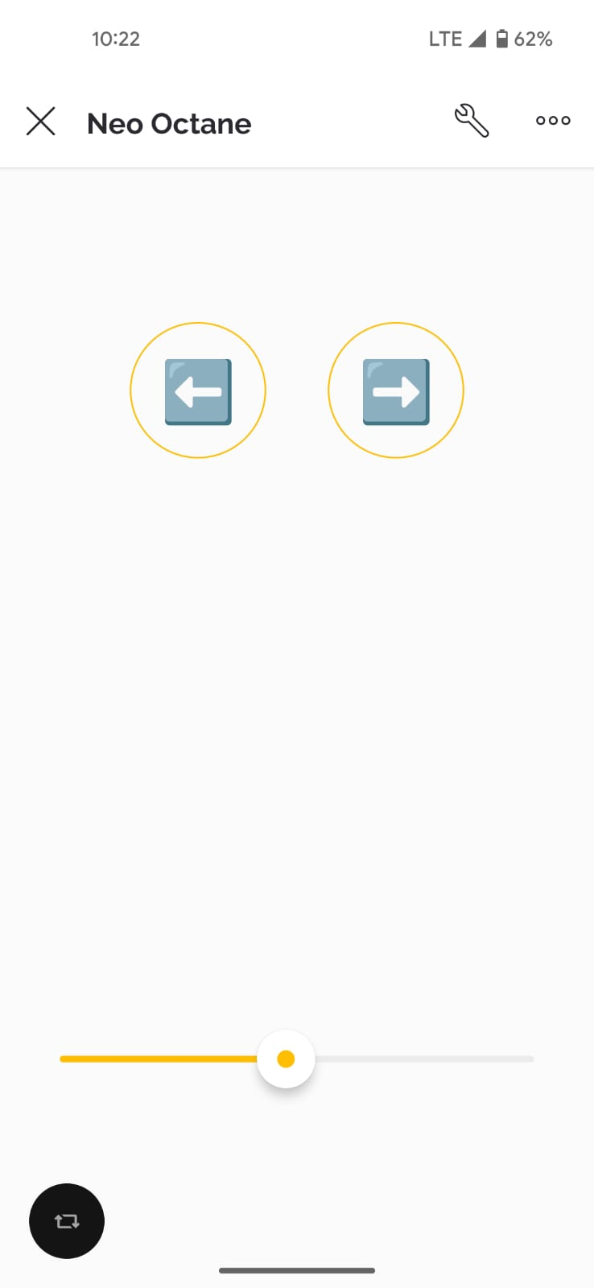
To steer the car, user must tilt the phone. The phone’s accelerometer value is sent to ESP through Dabble app which is casted into motor speeds. To turn the car to the right, the right motor speeds are set higher than the left motor and vice versa for the left.
🏎️Locomotion:
L298N is the brain behind motor control. Our main power supply, 3 18650 batteries, are connected to this module. The 5-volt supply from the module is used to power ESP32.
OUTA and OUTB are used to control two motors each for each side. ENA (enable A) is used to control the speed of the OUTA motors. ENB (enable B) is used to control the speed of OUTB motors. IN1 and IN2 are used together to control the direction of OUTA motors. IN3 and IN4 are used together to control the direction of OUTB motors.
IN(1/3) | IN(2/4) | Motor(A/B)
LOW | LOW | Stop
LOW | HIGH | Forward
HIGH | LOW | Backward
HIGH | HIGH | Stop

⚠️Obstacle Avoidance:
To avoid crashing into obstacles, we have used 2 infrared sensors. One sensor is placed at the front and the other one is at the back. The infrared sensor has one transmitter and one receiver. The transmitter continuously sends out infrared rays. If some obstacle appears in front of the sensor, then the transmitted rays are reflected off that object and they are detected by the receiver. The output pin connected between the Arduino and IR sensor is set to high meaning that an object is detected, and a notification is also sent to the user. You can also toggle obstacle avoidance if it is not required by pressing the Select button on the Dabble interface.

Challenges and Solutions:
- We initially used ESP32 because it has built-in Wi-Fi and Bluetooth module, but we had trouble interfacing it with ultrasonic sensors. The ESP microcontroller works on 3.3V logic but the ultrasonic sensor works on 5V logic.
- We used Blynk IOT to interface the car, but a noticeable delay was present in it. Blynk IOT works on Wi-Fi and all the inputs from the app were first uploaded to the Blynk cloud and from there they were transmitted to the ESP.
- The ultrasonic sensors we were using were very inaccurate due to which obstacle avoidance was also inaccurate. We also used trigger switches to stop the car as a back if a collision did occur but the issue with them was that the interrupt that it produced crashed the entire ESP controller. To solve both problems we used Infrared sensors instead. They were very accurate and after using them, there was also no need for trigger switches.
- Most of our challenges were simply avoided by using Arduino Uno as our microcontroller. Instead of using Wi-Fi in the ESP32 we switched to Bluetooth and connected its a module to Arduino Uno.

🔮Conclusion:
By using the Arduino microcontroller, we successfully built a Remote-Control car and interfaced it with the Dabble App. The car runs smoothly and is equipped with obstacle avoidance which successfully detects any object in its vicinity. In the future we can create a separate app to navigate the car and provide a more intuitive interface to the user. We can also add a camera at the front of the car and show the feed to the user.

